 | Kemankeş Karamustafa Paşa Mah.,  Mumhane Cad., No:50, K:2,  34425, Beyoğlu, İstanbul  www.artxist.com, info@artxist.com | BASIN BÜLTENİ

UNTITLED

09 - 25 Jul 2020

Ali Bilge Akkaya | Ansen | Aydın Berk Bilgin | Aylin Zaptçıoğlu | Burçin Başar | Emin Mete Erdoğan | Gülin Hayat Topdemir | Hüseyin Arıcı | Murat Palta | Seda Hepsev | Serkan Yüksel | Tayfun Gülnar

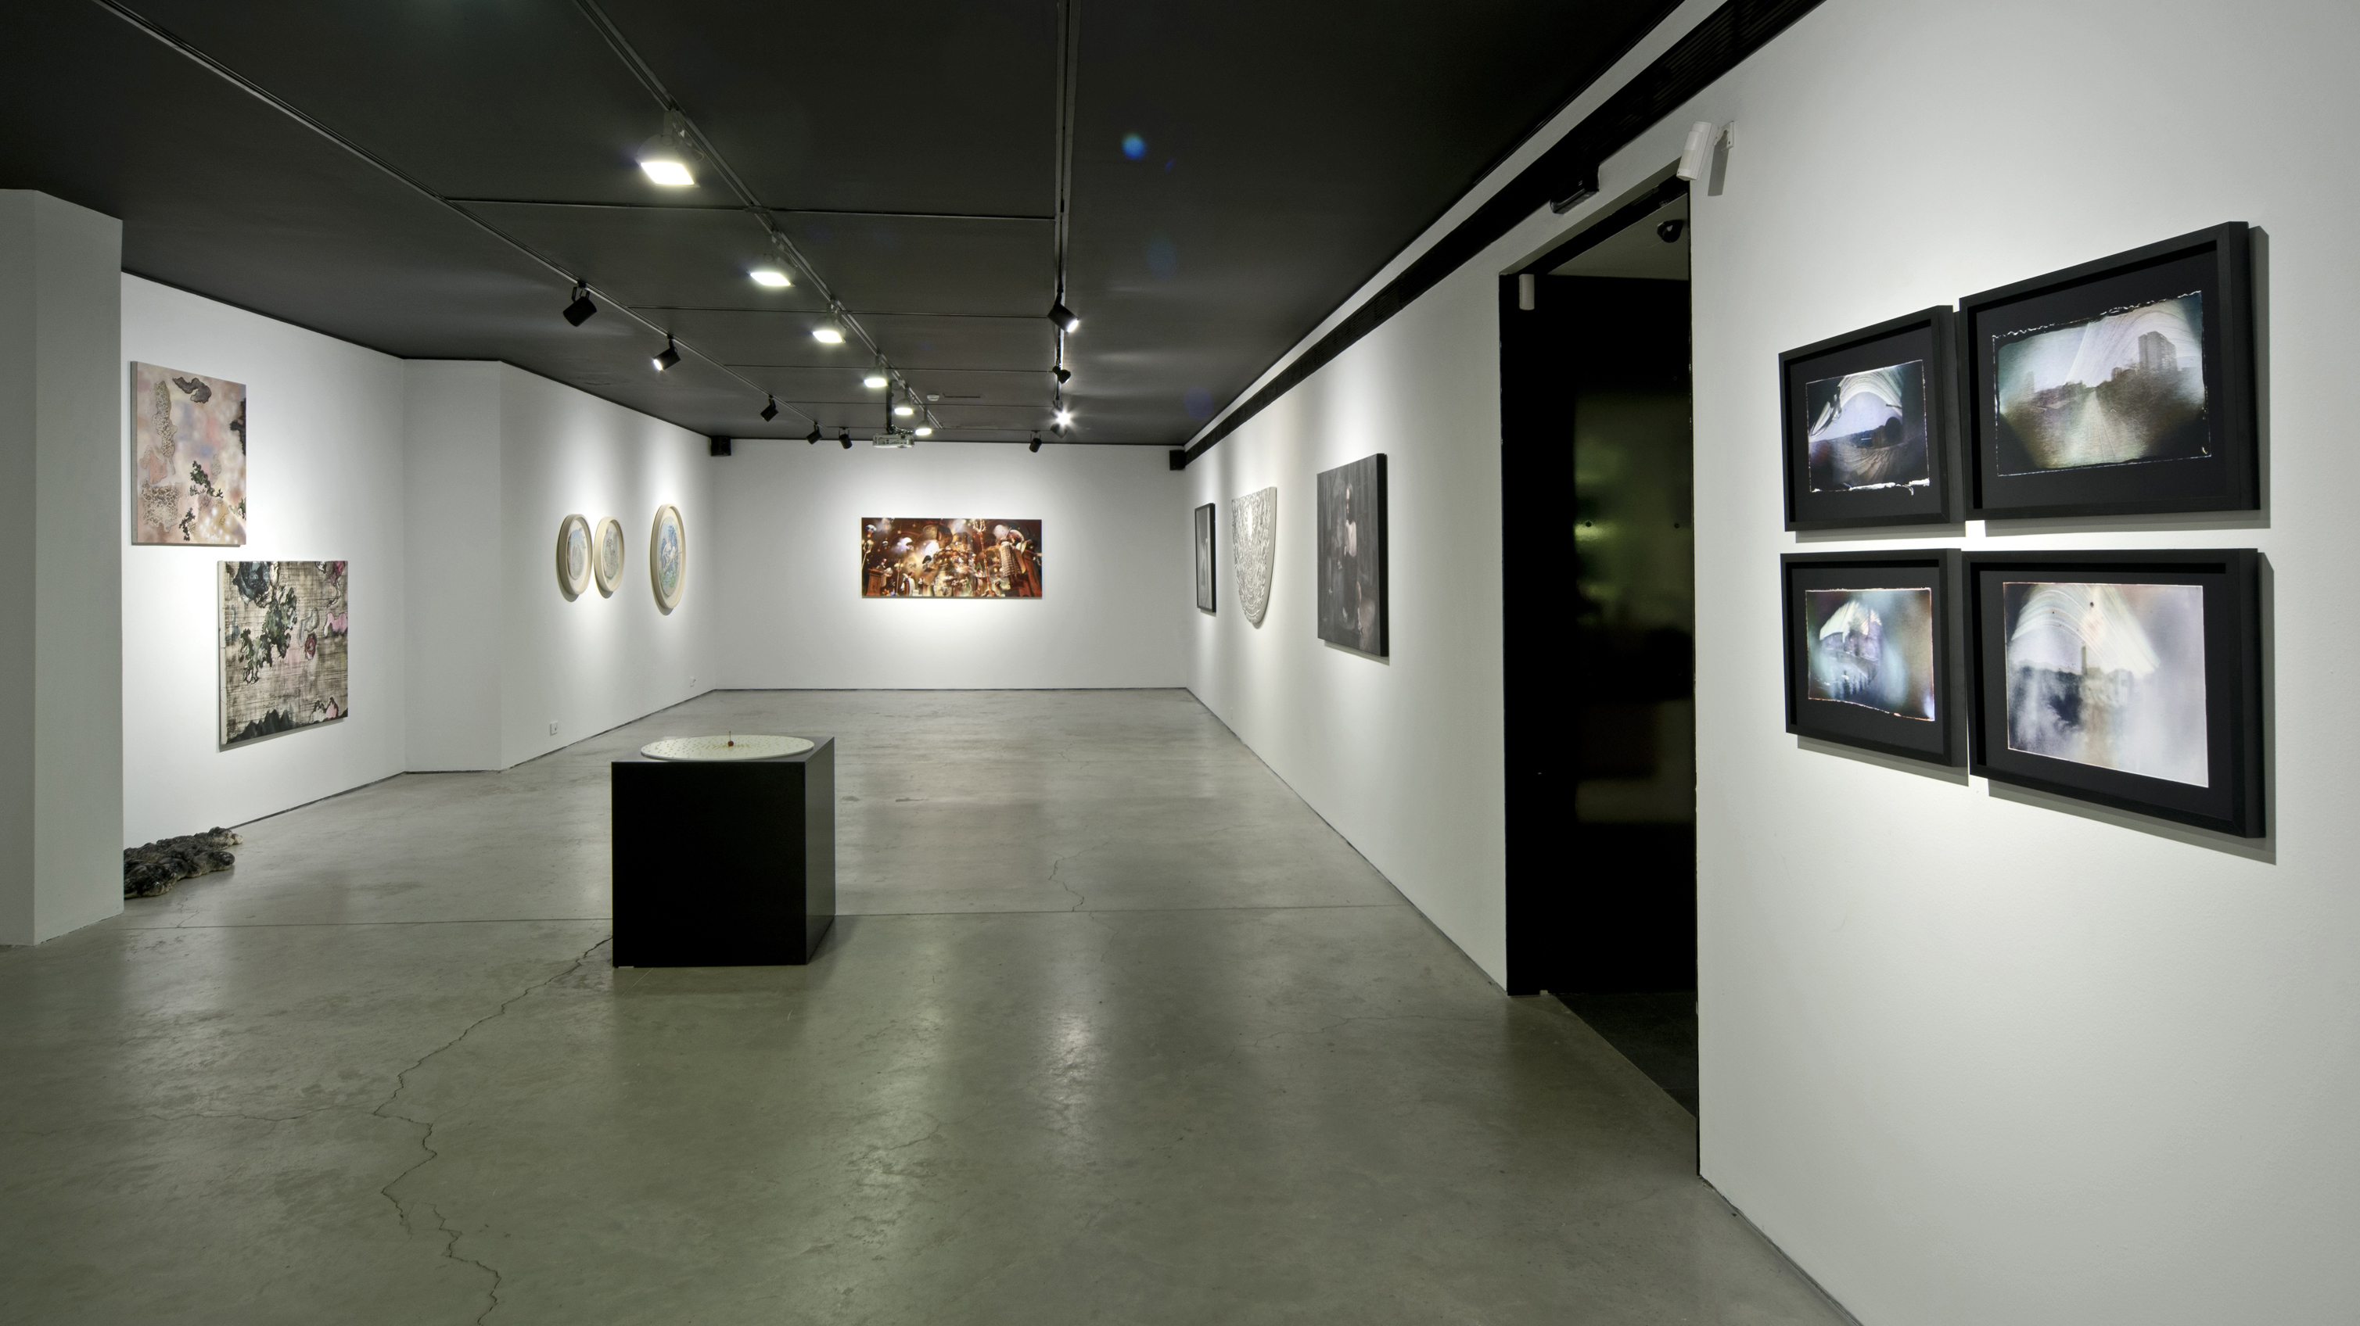

“Untitled” exhibition

x-ist will be open until July 25 under the "Untitled" event, together with artSümer, Mixer and Sanatorium. Within the scope of "Untitled" summer exhibition x-ist artists; Ali Bilge Akkaya, Ansen, Aydın Berk Bilgin, Aylin Zaptçıoğlu, Burçin Başar, Emin Mete Erdoğan, Gülin Hayat Topdemir, Hüseyin Arıcı, Murat Palta, Seda Hepsev, Serkan Yüksel and Tayfun Gülnar past and unseen works will be on the show. You can visit the event of "Untitled" from July 9 to July 25, Wednesday - Saturday, between 12:00-18:00 following the rules of social distancing.

melis@artxist.com
M. 0 535 555 35 36
T. 0 212 291 77 84

