 | Kemankeş Karamustafa Paşa Mah.,  Mumhane Cad., No:50, K:2,  34425, Beyoğlu, İstanbul  www.artxist.com, info@artxist.com | PRESS RELEASE

Tayfun Gülnar’s second solo exhibition “A Momentary Silence” to be held at
x-ist will meet the audience between October 24 – December 7, 2019.

TAYFUN GÜLNAR
A MOMENTARY SILENCE

Setting up dystopian scenes in his works, Tayfun Gülnar connects with his previous series in his second solo exhibition at x-ist and focuses on a world cleared of human elements as a result of consumption habits.

The artist, who in his first exhibition “Chromophobia” depicted a society that has abandoned its humanity, confronts the audience with a universe determined by new fictional forms. The artist’s interest in geological and biological transformations that are born, waiting and developing in the shadow of issues of social violence becomes a guide for creating these new forms in his paintings.

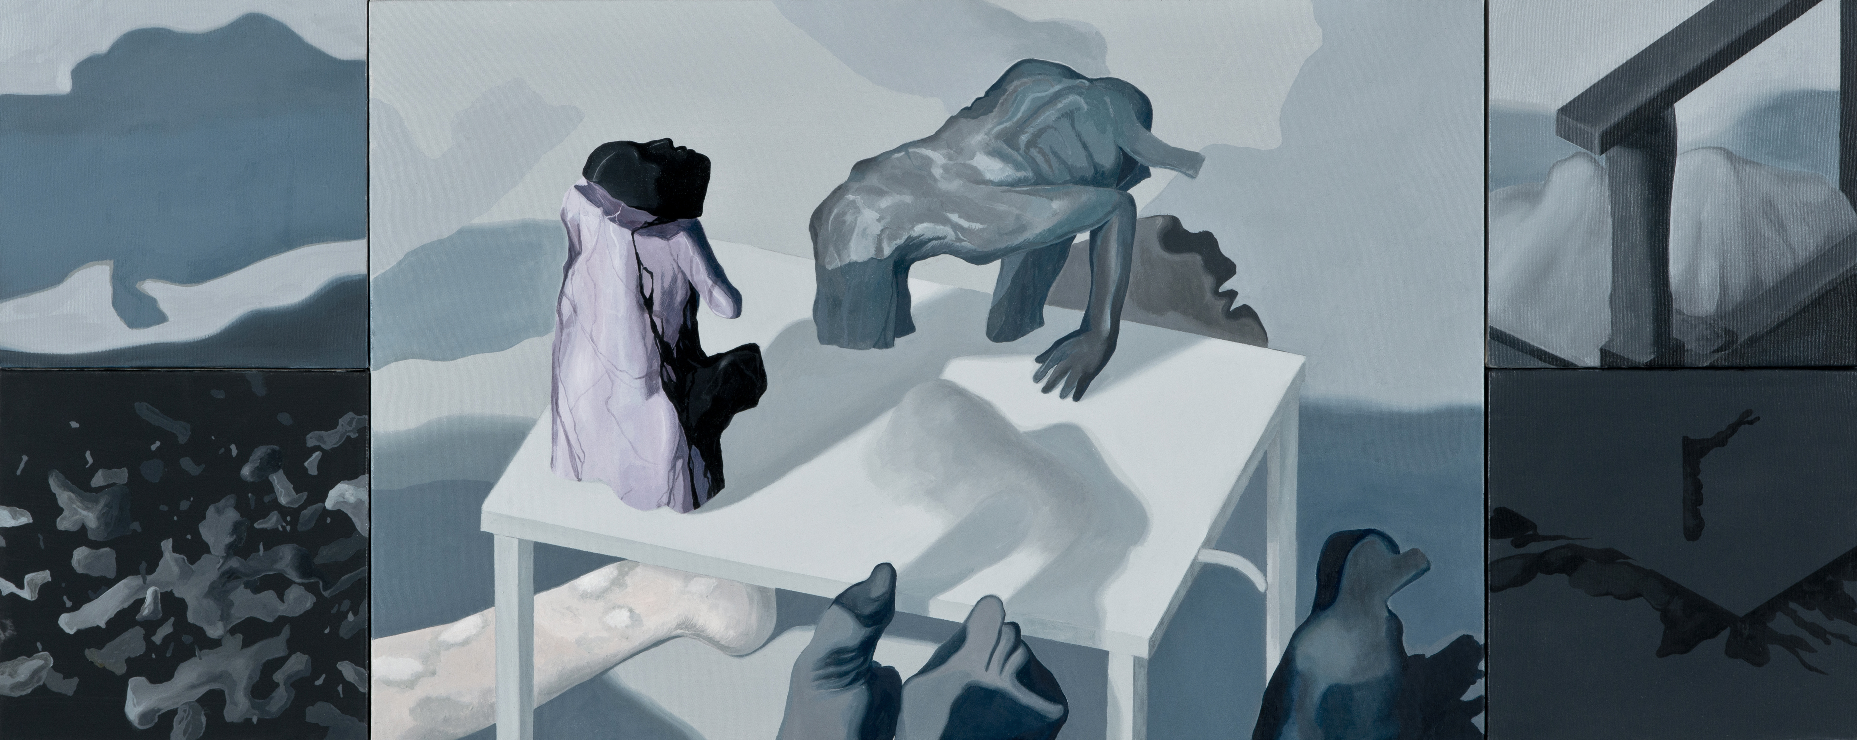
“Ongoing Formation”, Oil painting on canvas, polyptych, 60 x 150 cm, 2019

The work in the exhibition entitled “Conflicting Side of the World” illustrates the manifestation of human-based mobility and mass violence, the look at our history in a world setup where humanity comes off the stage. In this context, the intense inaction and the constraint of biological forms in other works create a narration that can be read in terms of two phases of time as anthropocene and post-human. “Annihilation & Genesis” intertwines the bitter end of manmade engineering wonders that are unable to resist time with the act of rendering visible the search for hope regarding aliveness in a universe after the apocalypse along with the issues of transience and permanence. When read in terms of transience, which is one of humanity’s most fundamental truths and problems that it has been trying to overcome throughout its own history, architectural domination approves people’s domination on people by making one experience the violence of the sign of development and colonization in the most obvious way. On the other hand, the works entitled “Fragmentation Process of Monuments”, “Molting” and “Oxygenless” host the absurdity of challenging the destructive and transformative feature of time.

Tayfun Gülnar expresses his elaborative style in his paintings with a use of colours reduced to monochrome and blue tones. His second solo exhibition at x-ist entitled “A Momentary Silence” can be visited between October 24 – December 7, 2019.

For more detailed information, please consult Gamze Kantarcıoğlu from x-ist.

gamze@artxist.com
M. 0 536 255 95 12
T. 0 212 291 77 84

