 | Abdi İpekçi Caddesi Kaşıkçıoğlu Apt. No:42 D:2 34365 Nişantaşı İstanbul www.artxist.com  info@artxist.com  T. +90 212 291 77 84 F. +90 212 343 69 35 | PRESS RELEASE

x-ist will host Serkan Adın’s solo exhibition entitled “e” between April 7 – May 7, 2016.
SERKAN ADIN
“e”
Serkan Adın, whose works have been exhibited before in different countries such as Canada, the United States and Japan, being in the first place, meets the art audience with his sixth solo exhibition “e” at x-ist.

The “e” symbol, which is placed on the labels of packaged goods and indicates that the volume or weight of the product might vary, warns us for the margin of error. In the recent exhibition of Serkan Adın, whose focal point of work has always been the “woman” for almost 15 years, we observe this time a criticism concerning how the female figure is packaged and objectified. The very shortcut method of making the object attractive is the idea of presenting it with a package that will render it appealing, and the artist begins to examine the view on the female figure from here. Making use of the “e” symbol, which shows that we accept with its missing or exceeding part that what is wrapped up for being preserved or rendered attractive, Serkan Adın names the exhibition after this reference of +/-.
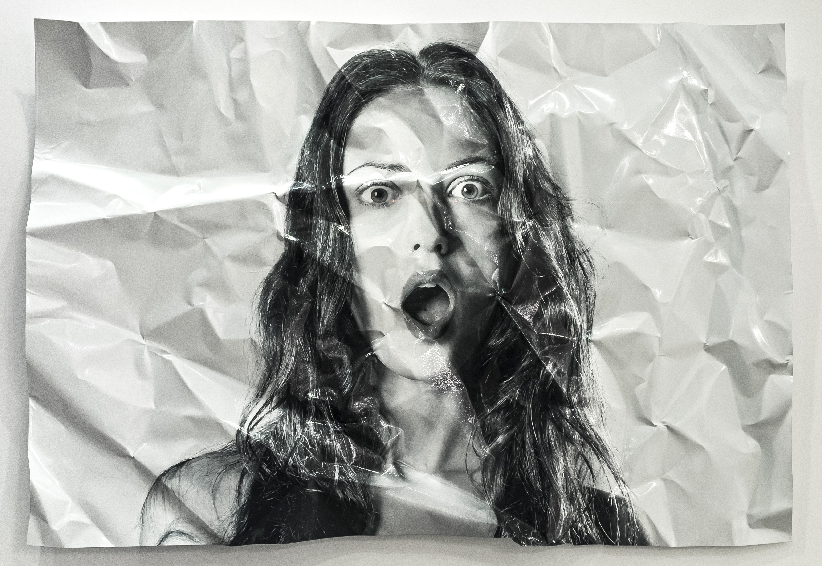
“Love, S.” acrylic on aluminium, 126 x 180 cm, 2015.
Serkan Adın, who uses traditional and technological techniques together in his works and has won awards with his printmaking techniques, such as from the 11th International Varna Biennial (2001) in Bulgaria, the Printmakers (2002) in Spain, and the 4th KIWA-Kyoto International Woodprint Association (2003) in Japan, brings together again different materials and techniques in his works taking part in his exhibition entitled “e”. Separating the visuals that he prepared first in the digital environment according to colour spaces, the artist makes the colour chart of each visual. 6.000 to 90.000 colour particles matched on the chart are painted with the help of an insuline injector according to the colour that they represent with the colours and tones varying between 150 to 200. Applying new methods in his recent exhibition, the artist makes a closer contact with the audience by adding an interactive dimension to his works such as his triple series “Cheap Melancholy” containing magnetic installations open to the audience’s intervention or his work “Three Absent Colours” referring to the colours of the French flag and changing colours with LEDs.

Serkan Adın’s exhibition entitled “e” can be seen between April 7 – May 7, 2016 at x-ist.

SERKAN ADIN I IZMIR, 1977

Adın graduated from Dokuz Eylul University, Fine Arts Faculty, Painting Department. Following his first show “Instant Message” (2005) in x-ist, Adın had five more solo shows at x-ist: “Instant Message” (2005), “Save As” (2007), “E-Doll” (2008), “Killjoy” (2011) and, “AnonymoX” (2014) in x-ist.

Awarded by Bulgaria (11th International Varna Biennial, 2001), Spain (Printmakers, 2002) and Japan (4. KIWA-Kyoto International Kyoto Woodprint Association, 2003), 11th Printmaking “Ostrow Wiekopolski” award (Spain, 2005), the artist exhibited in several countries including Bulgaria, Romania, Switzerland, Macedonia, Japan and Korea. Adın took place in several group shows and art fairs including “Young Expansions” (Pera Museum, 2005), and Contemporary Istanbul’07, 08, 09, 10, 11, 12, 13 & 15, ShContemporary’09 (Shanghai Asia Pacific Contemporary Art Fair), St-art 2009 (14th European Contemporary Art Fair, Strasbourg, France), Art Beat 2011 (Istanbul), VIP Art Fair 2012 and ArtInternational 2013, 2015 (Istanbul) fairs, “Caixanova” Printmaking Bienalle,Ourencse/Spain (2006), 4.BIMPE. Gallery San Chun in Calgary/Canada (2006), Harlech Bienali "Print Open". Theatr Ardudwy, Wales, England (2002), 8th International Printmakers and Painting Exhibition “GRAFINNOVA 2002”.
In 2010, the artist participated in the show titled “Istanbul Cool! What’s Happening in Contemporary Turkish Art Now” in Leila Taghinia-Milani Heller Gallery, (New York, USA). Serkan Adın is featured in the book “Unleashed: Contemporary Art from Turkey” first published in 2010.

For more detailed information, you can consult Gözde Ulusoy from x-ist.

gozde@artxist.com
M. 545 357 60 70
T. 212 291 77 84

