 | Abdi İpekçi Caddesi Kaşıkçıoğlu Apt. No:42 D:2 34365 Nişantaşı İstanbul www.artxist.com  info@artxist.com  T. +90 212 291 77 84 F. +90 212 343 69 35 | PRESS RELEASE

x-ist will be at 42 Maslak with a selection of works by Erkut Terliksiz, Ekin Saçlıoğlu and Seda Hepsev between March 10 – April 8, 2016!

x-ist @ 42 MASLAK

ERKUT TERLİKSİZ I EKİN SAÇLIOĞLU I CEREN OYKUT

At Art!Space Gallery, the gallery space of 42 Maslak which has set out with the aim of bringing life and art together, a selection of works by Erkut Terliksiz, Ekin Saçlıoğlu and Seda Hepsev will meet art lovers. While one floor of the two-storey space is reserved for the works of Erkut Terliksiz, the works of Ekin Saçlıoğlu and Seda Hepsev will be located on the other one.
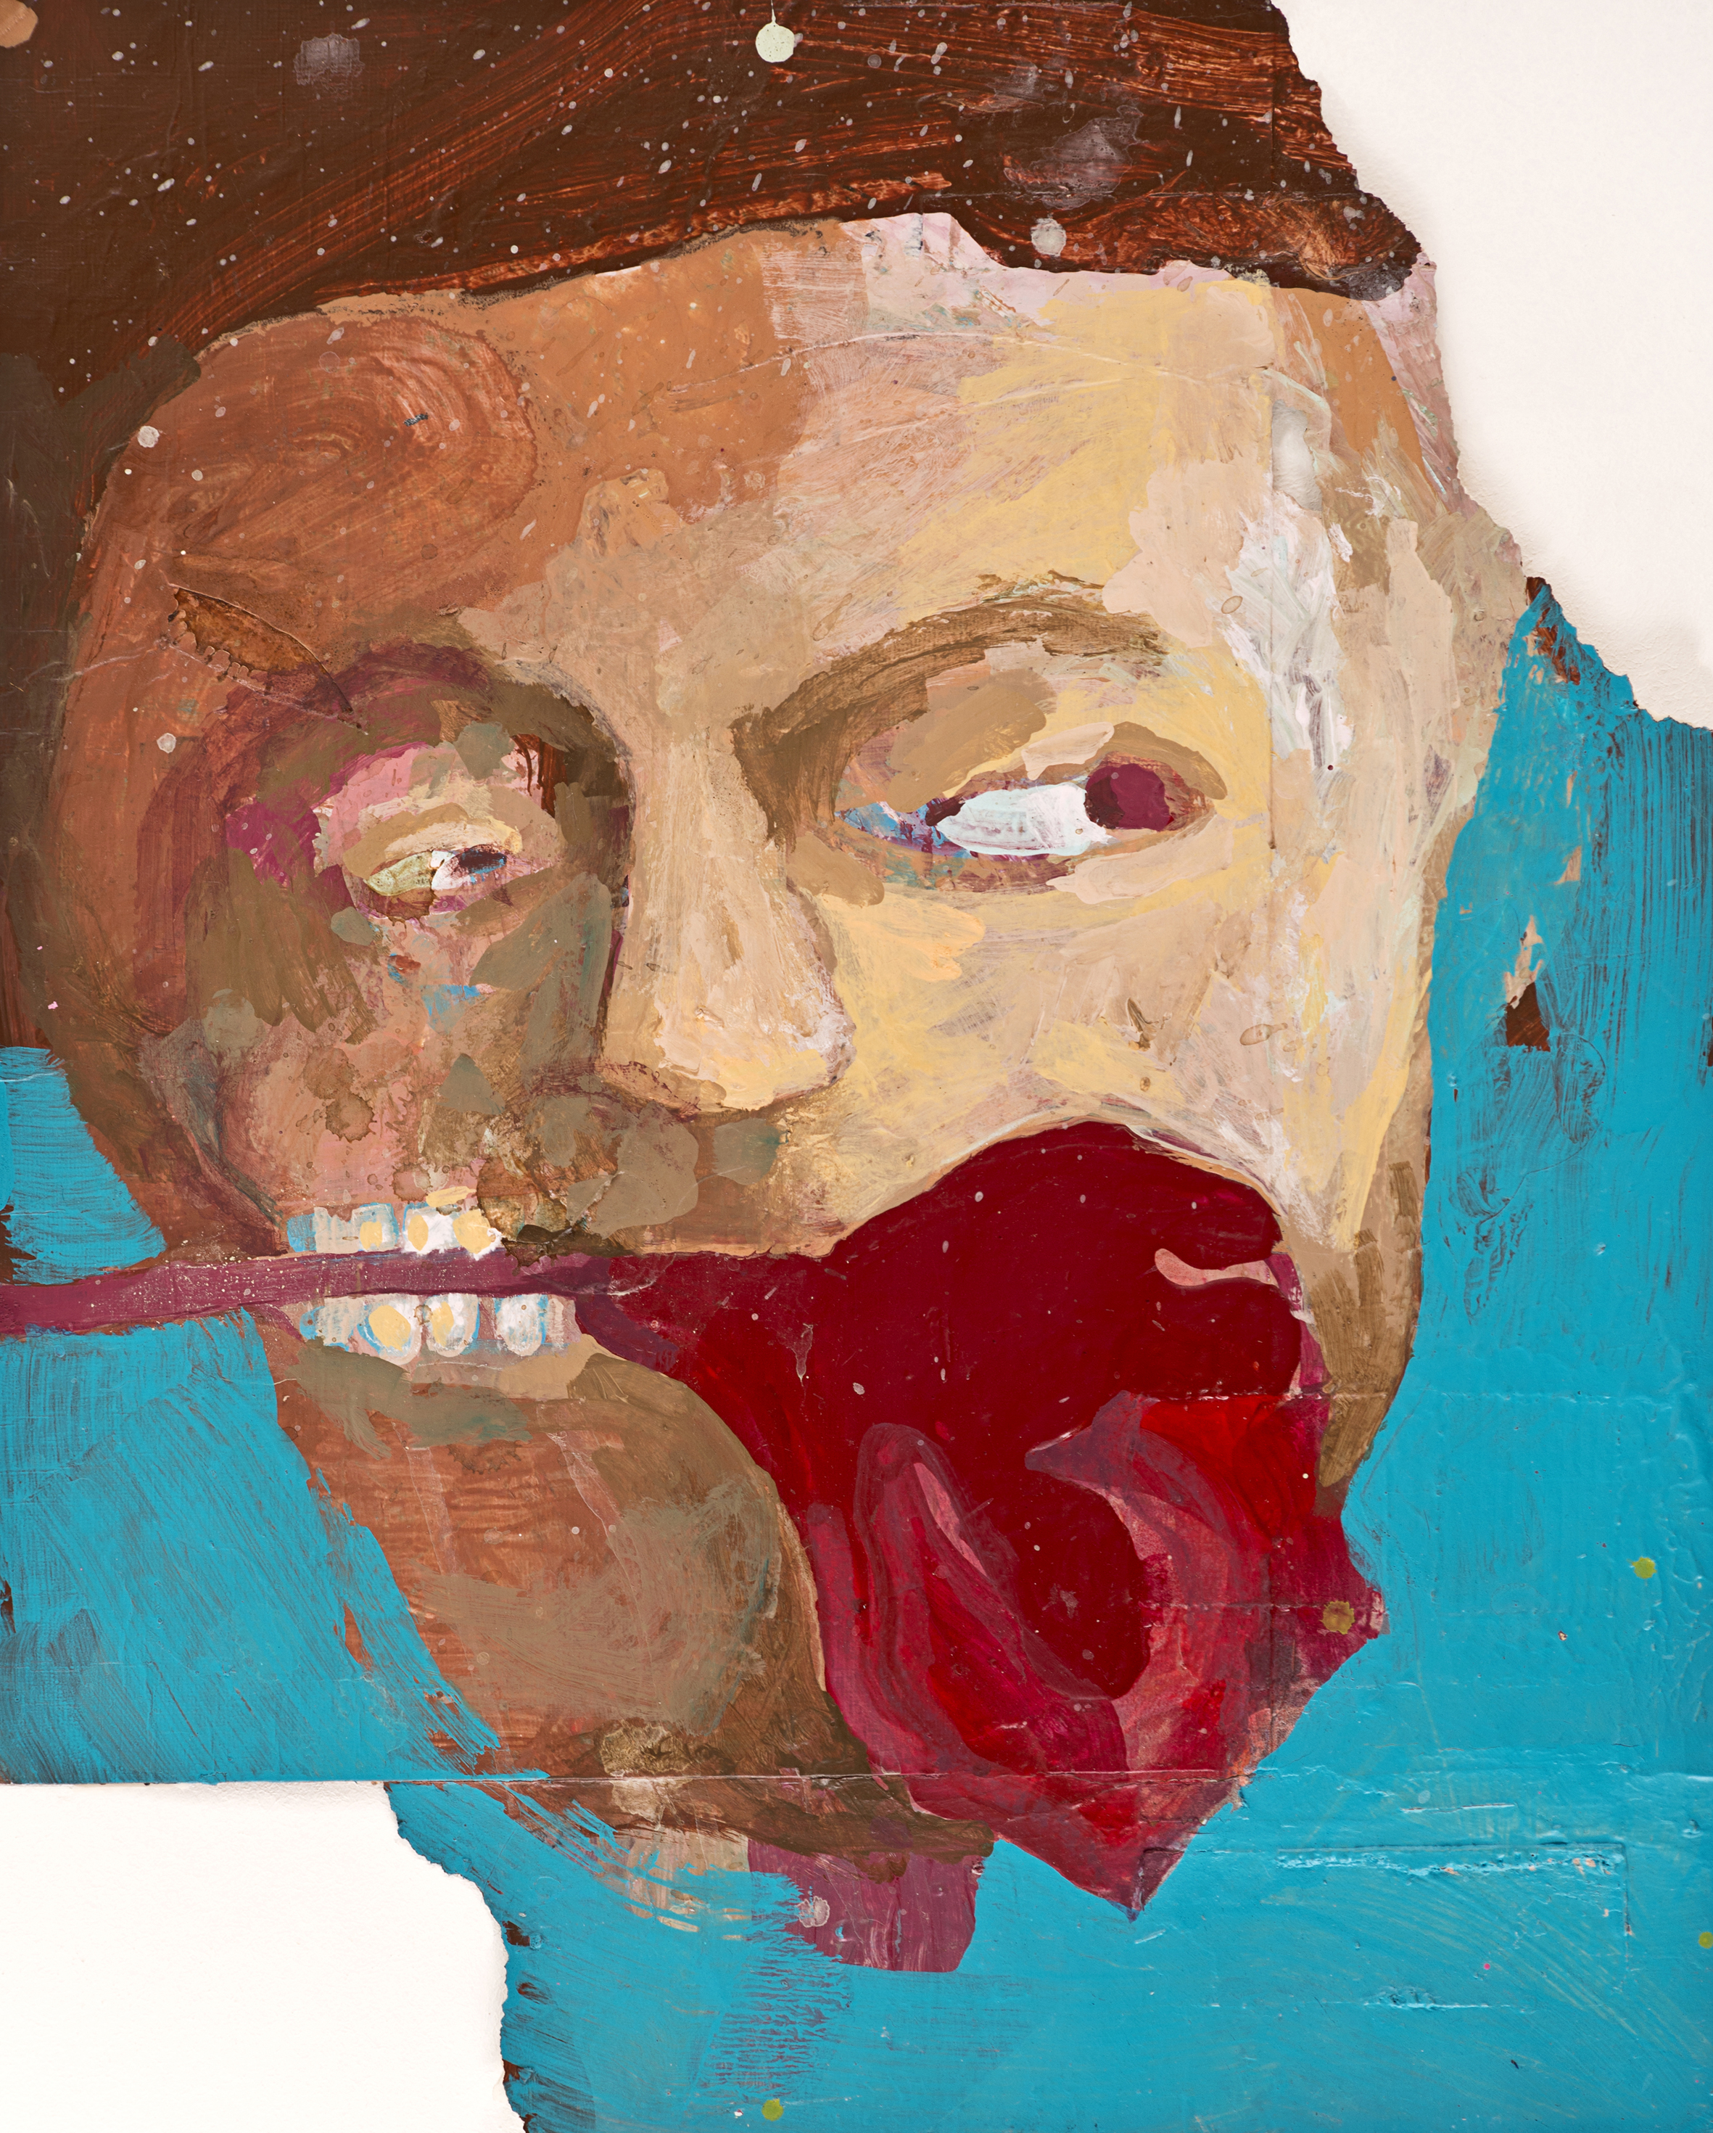

Erkut Terliksiz, “Dripping Venom”, mixed technique on paper, 43x34.5 cm, 2014.

Having a predominance of tale-like narration and use of figures gradually becoming abstract, the works of Erkut Terliksiz meet the audience on the floor reserved for him with the effect of a solo show presentation. The artist, who has concentrated on the use of experimental materials in the recent period, takes part in the exhibition with his works created with found materials.

Ekin Saçlıoğlu, who always surprises the audience with her use of creative and bold materials, meets the audience with her works and paintings. She meet the audience with her oil paintings and drawings from her solo exhibition “Pick and Keep”, (2015) New World and Antiques series and also she creates duality between fiction and reality with her hologram mosaics exhibited previously at her solo show “Pothole” (2012).

Seda Hepsev takes part in the exhibition with her acrylic works on canvas which, based on the artist’s personal experiences and observations, analyze the social relationship forms under the male-female, family or corporate roles with a humorous language.

The exhibition can be seen at Art!Space Gallery, the gallery space of 42 Maslak, between March 10 – April 8, 2016.

