 | Kemankeş Karamustafa Paşa Mah.,  Mumhane Cad., No:50, K:2,  34425, Beyoğlu, İstanbul  www.artxist.com, info@artxist.com | PRESS RELEASE

SERKAN YÜKSEL
A HIGH WIND WAS WANDERING AROUND THE SQUARE

Serkan Yüksel will meet the audience with his sixth solo exhibition, and the first one to be held under x-ist’s representation, entitled “A High Wind Was Wandering Around the Square” between May 9 – June 15, 2019.
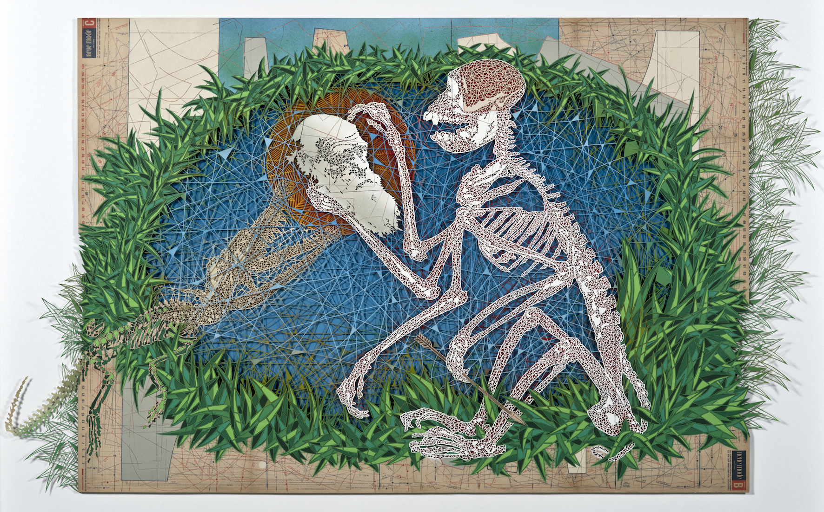
“To Be Was Not To Be”, Manual cutting and spray paint on dress pattern sheet, 107x150.5 cm, 2019

Conveying his criticism regarding contemporary problems by means of strong symbols and images, Serkan Yüksel meets the audience with his first solo exhibition at x-ist between May 9 – June 15. The voids meticulously created by him and his powerful setup rendering his multilayered surfaces impressive underlie his original critical expression.

In his political criticism, Yüksel focuses on social memory as well as the individual’s memories. He finds the traces of the past sometimes in a son being the target instead of an apple and sometimes in a timid rabbit being digested. The artist directs his look towards humanity’s most important problems, sometimes towards existence and sometimes towards annihilation… He searches for the truth behind the visible in myths and in science, from William Tell to Darwin. Yüksel’s use of metaphor and his elaborative setup leads to a deliberate thinking process.

From the exhibition text prepared by Derya Yücel:

“…The plastic dynamism of the pictures that Serkan Yüksel creates by meticulously cutting out, separating, sculpting, combining, transforming layer by layer from maps, models, dress patterns and newspapers is harsh, destructive and violent as well as fragile. Tracking the universe that keeps swirling in a vortex full of people, animals, human-animals, things and undefinable creatures erupting from all that signs, metaphors and symbols, the artist looks for human vulnerability in the vague and slight but that painful paper cut. By pulling out the hope of healing in the ache of the cut and the trace of the wound, he is concerned about shaping a symbolic tale based on imagination against the reality created by power, his subjective reality by means of creative act. This is because the vulnerable (fragile) one is not the victim, on the contrary, can be open to act, be influenced and influence in return both individually and collectively. The act of the artist is like continuing a battle in spite of dust and a strong wind on humanity’s decadent, morbid historical battlefield loaded with darkness and tragedy. This is because the formation of the line (cut) between the pains that we have surrendered ourselves to and that we can fight to transform is fundamentally political.…”

Serkan Yüksel’s solo exhibition entitled “A High Wind Was Wandering Around the Square” can be visited until June 15 at x-ist’s new address Karaköy Juma.

For more information, please consult Gözde Ulusoy from x-ist.

gozde@artxist.com
M. 545 357 60 70
T. 212 291 77 84

Conveyed by Alyson Cole from Shklar, Judith N., The Faces of Injustice, “All of Us Are Vulnerable, But Some Are More Vulnerable than Others” [translated into English by Güher Gürmen for this text from the Turkish translation in Cogito, YKY, Sayı 87, Yaz 2017, s. 90]

