 | Kemankeş Karamustafa Paşa Mah.,  Mumhane Cad., No:50, K:2,  34425, Beyoğlu, İstanbul  www.artxist.com, info@artxist.com | PRESS RELEASE

Gülin Hayat Topdemir, who joined x-ist this season, meets the audience with her first solo exhitibion “Doors to Ustopia” at the gallery between December 12, 2019 – January 18, 2020.

GÜLİN HAYAT TOPDEMİR
DOORS TO USTOPIA

Gülin Hayat Topdemir, who creates a distinctive language with her meticulous use of paint and elaborative style, focuses on the utopias within dystopias in her first solo exhibition entitled “Doors to Ustopia” at x-ist.

The artist conveys surreal stories regarding women and women’s world with a realistic style and in an impressive way by using Chiaroscuro, the local lighting technique dating back to the Renaissance, and places women into a dystopian setup by means of the venue and symbols that she uses in this exhibition.
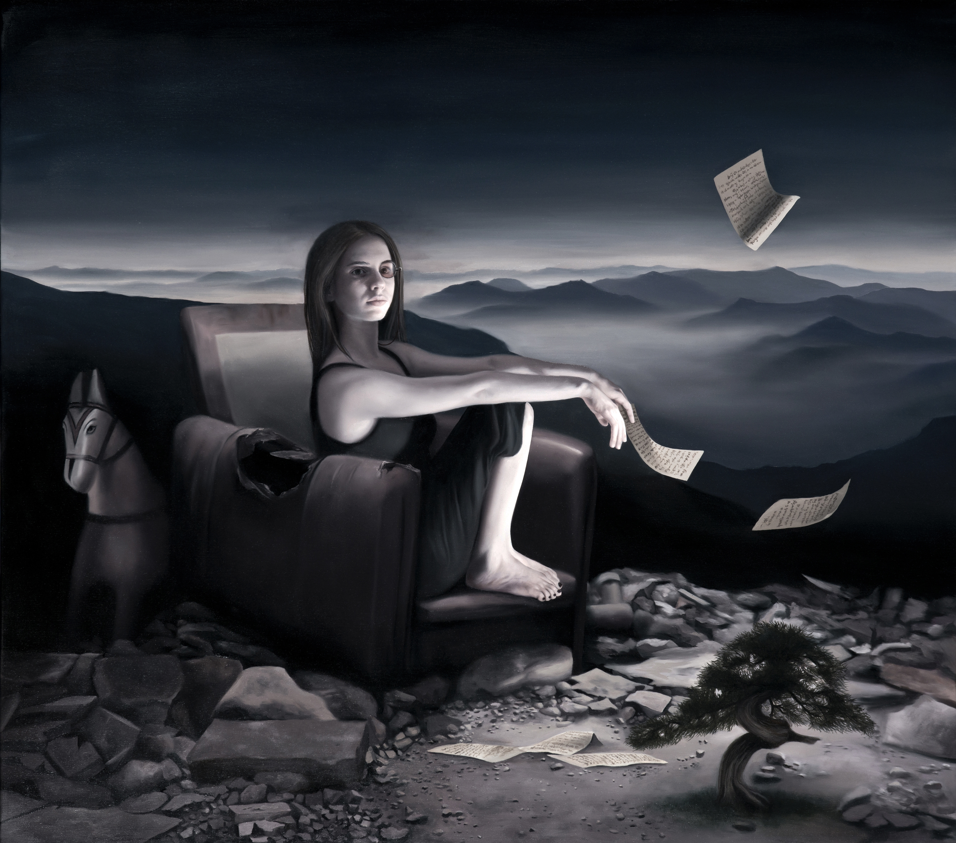
“Storyteller”, Oil on canvas, 105 x 120 cm, 2019

According to author Margaret Atwood, a utopia is hidden within each dystopia. The dystopia is, in a sense, the antithesis of utopia and both implicitly include each other’s manifestation. Each event includes the interaction of phenomena and comes into existence as a result of this interaction. The world set up by Topdemir is named after the term “ustopia” suggested by Atwood as a combination of these two concepts.

As can be understood from Topdemir’s approach and the title given to the exhibition, the works in the exhibition refer to a psychological destruction and the hope expected thereafter. Women placed in dark spaces make a call for change and transformation instead of acceptance with their gazes. While idle interiors express a mental breakdown, the inertia of women in uncanny hours remind of waiting for serenity and re-enlightenment. The door image often encountered in the works in the exhibition show that there is always a way out.

Featuring paintings that contain a romantic and lyrical language as well as a strong reaction against the society and taboos, Gülin Hayat Topdemir’s first solo exhibition entitled “Doors to Ustopia” at x-ist can be visited between December 12, 2019 – January 18, 2020.

Please consult Gamze Kantarcıoğlu from x-ist for more detailed information.

gamze@artxist.com
M. 0 536 255 95 12
T. 0 212 291 77 84

