 | Abdi İpekçi Caddesi Kaşıkçıoğlu Apt. No:42 D:2 34365 Nişantaşı İstanbul www.artxist.com  info@artxist.com  T. +90 212 291 77 84 F. +90 212 343 69 35 | PRESS RELEASE

Murat Palta’s second solo exhibition to be held at x-ist entitled “Gods, Monsters & Men” will meet the audience between February 1 – March 3, 2018.

MURAT PALTA
GODS, MONSTERS & MEN

Bringing together especially the form of classical miniature and elements of popular culture in a distinctive style, Murat Palta focuses this time on mythology’s way of narrating god, men and monsters in his second solo exhibition to be held at x-ist. The artist, who interprets mythology’s strong symbolism through his original and witty language, brings together in his exhibition characters that still continue their existence today.

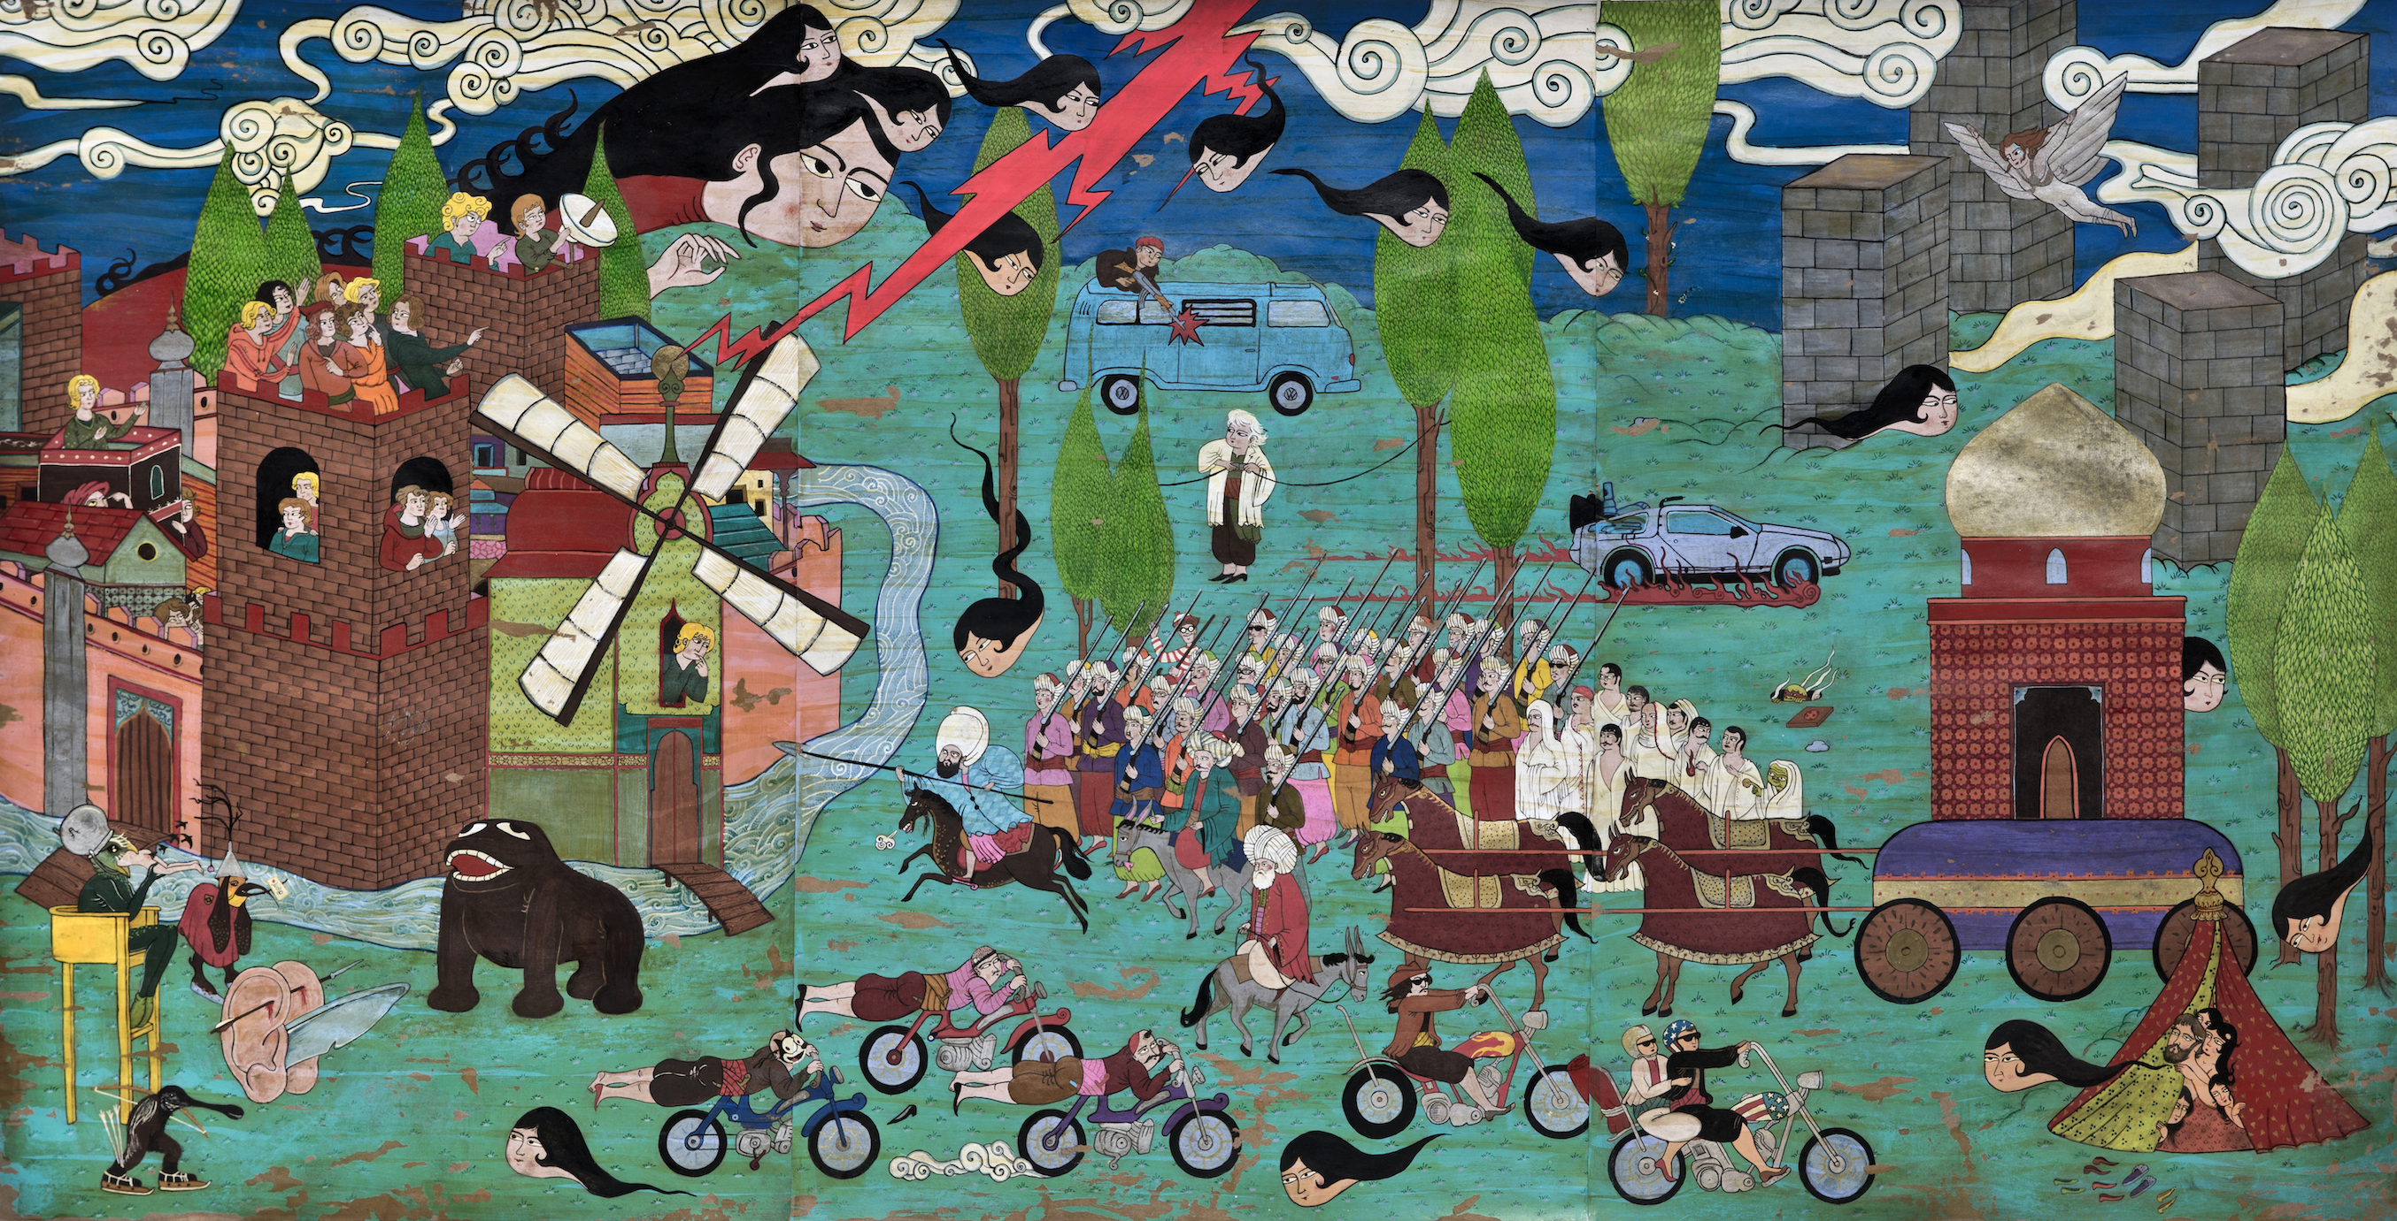
Murat Palta, "On Leather Steeds They Ride", Kraft üzerine karışık teknik I Mixed media on craft, 80 x 160 cm, 2018

Having focused on cult literature and cinema in previous exhibitions held both at x-ist and in Russia and France, Murat Palta gravitates towards mythology’s way of depiction in his exhibition "Gods, Monsters & Men". The artist focuses on the fact that all characters are living at the same time and in the same world although being at different places and looks for the answer of the following question: “What are and can be the roles of gods, men and monsters in the events taking place or are likely to take place today?”

While extending the limits of traditional art, the artist uses all the absurd details of popular culture with an understanding of dark humour and meets the audience with his works produced with different techniques and materials. Questioning miniature’s structure that is based on the idea of multiple scenes on a single surface by conveying it to three-dimensional works and in terms of the artificial depth perception that it creates, Murat Palta will surprise his followers with a collection including a variety of hand-woven rugs, mixed media on paper and MDF, wall sculptures and video animation.

Murat Palta’s second solo exhibition entitled "Gods, Monsters & Men" to be held at x-ist can be visited between February 1 – March 3, 2018.

Please consult Gözde Ulusoy from x-ist for more information.

gozde@artxist.com
M. 545 357 60 70
T. 212 291 77 84

