 | Abdi İpekçi Caddesi Kaşıkçıoğlu Apt. No:42 D:2 34365 Nişantaşı İstanbul www.artxist.com  info@artxist.com  T. +90 212 291 77 84 F. +90 212 343 69 35 | PRESS RELEASE

For the first time in Istanbul, x-ist will host Malasian artist Kent Keong Tan’s solo exhibition “Floating Dreams” between June 24 – August 26, 2016.

KENT KEONG TAN
“FLOATING DREAMS”

The spirit of Kent Keong Tan's paintings comes from his childhood memories, and his experience of different cultures as he grew up.
He paints neglected corners, abandoned houses, deserted rooms and countryside poles, which turn into surreal scenes on the canvas as memory and reality blend together.
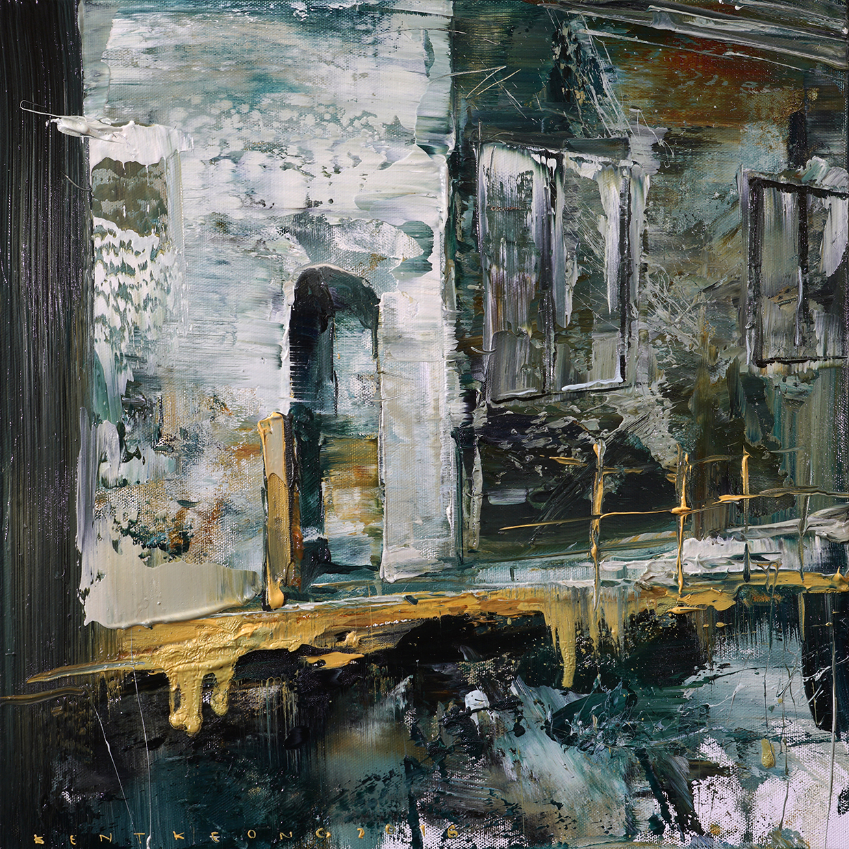
Kent Keong Tan , “Street”, 40 x 40 cm, oil on canvas, 2016.

Perhaps there is an inseparable relationship between Taiwanese and Southern Asia culture so that Kent Keong Tan often combines the scenery in Taiwan with his childhood memories from Malaysia. In his abstract expressionist paintings, Tan also incorporates signs of Zen belief.
The exhibition "Floating Dreams" can be seen at x-ist until August 26, 2016.

For further information please consult Gözde Ulusoy from x-ist.
gozde@artxist.com
M. 545 357 60 70
T. 212 291 77 84

Kent Keong TAN I Malaysia, 1979

Education
2008-2013 National Taiwan University Of Art (MFA)
2004-2008 National Taiwan University Of Art (BA)

Selected Solo Exhibitions
2016 “Theatre of the Contained”, Art Central, Affinity for ART, HK
2014 “Nomads”, Flugent ART Gallery, Macau
2013 “I Still Haven’t Found What I’m Looking For”, Bellavita B1 Gallery,
Boss Gallery, Taipei
2013 “An Elapsing Phenomenon of Peace Land”, Boss Gallery, Taipei
2011 “GUNDAM 32”, Boss Gallery, Taipei
2010 “Toy dreamer”, WAWOO Art Space, Kaohsiung
2010 “Rippling Of The Will”, CYCU Art Center, Taiwan
2009 “Toys Serial 002”, Hwa Kang Museum, Taipei
2009 “Toys“, National Taiwan Arts Education Center, Taipei
2001 “2001 Solo Exhibition”, Pingfan Gallery, Malaysia

Selected Group Exhibitions
2015 “Keywords: Wild Legend“, Juming Museum, Taiwan
2013 “From Subverting Reality to Creating Reality“, Asia Museum of Modern Art, Taiwan
2011 “Follow me to travel it“, Pingtung Art Museum, Au Dot Art Space, Taiwan

Selected Art Fairs
2016 Art Stage Singapore 2016
2016 Poly Macau Hotel Art Fair, Macau.
2015 Affordable Art Fair Hong Kong, 2015

Awards
2009 Won the “1st Prize in the Police Festival Art Exhibition of Taipei County”, Taiwan
2009 Winner of “Best Performance Award of Banqiao Art Exhibition”, Taipei, Taiwan
2009 Winner of “Best Creative Award of National Taiwan University of Arts”, Taiwan
2008 Winner of “Best Performance Award of Kingcar Arts Exhibition”, Taiwan
2008 Won the “1st Prize in the Graduate of National Taiwan University of Arts”, Taiwan

