 | Kemankeş Karamustafa Paşa Mah.,  Mumhane Cad., No:50, K:2,  34425, Beyoğlu, İstanbul  www.artxist.com, info@artxist.com | PRESS RELEASE

“Plants, Animals and Buildings,” Emin Mete Erdoğan’s third solo exhibition at x-ist, meets the audience between
February 27 and April 4, 2020.

EMİN METE ERDOĞAN
PLANTS, ANIMALS AND BUILDINGS

In his third solo exhibition at x-ist, “Plants, Animals and Buildings,” Emin Mete Erdoğan creates a world where there are no humans but one can still trace them through representations.

In his new series, we see plants and animals in buildings where we hope to see humans. Inhabiting the building blocks that expand into eternity, these creatures seem to live in their natural habitat.
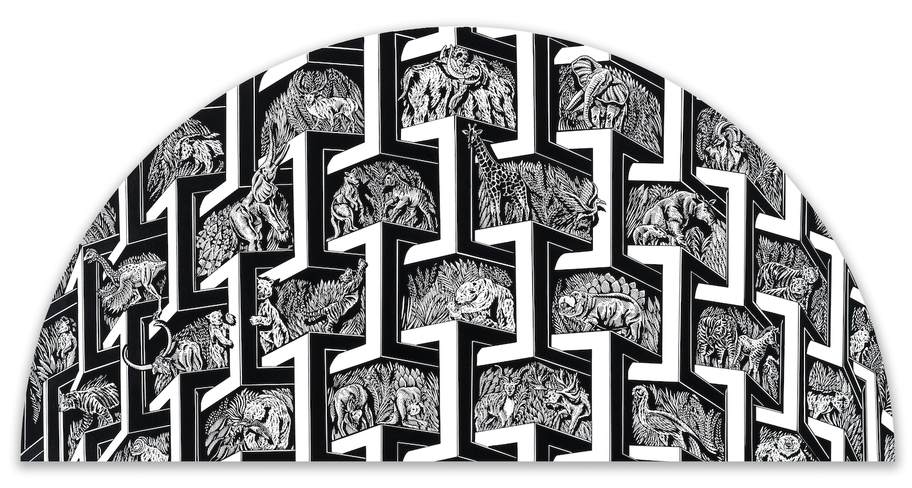

“Plants, Animals and Buildings VIII”, Acrylic ink on canvas, 50 x 100 cm, 2019

“The name of the exhibition bears an irony. After plants and animals, you expect to see humans. But, in this exhibition, I used buildings as metaphors of human mind instead of humans themselves,” says Emin Mete Erdoğan, who turns human-made buildings into a type of forests of caves, i.e. natural habitats, by inhabiting plants and animals in these dense geometrical structures. In this world where humans have lost power and control and that is dominated by nature, the possibility of the human extinction is quietly relayed to the audience.

In this exhibition, Emin Mete Erdoğan, who strives to create a visually endless sense of unity, mostly uses agonic canvases such as circular and elliptical. Using acrylic ink in his works, the artist aims to ask questions such as “Can a human-made inanimate structure become nature? Is humankind opposed to nature or has it been a part of nature since the very beginning? What is the dialectic between animate and inanimate? What are the dynamics of the relationship between humankind and nature?”

Emin Mete Erdoğan’s third solo exhibition at x-ist, “Plants, Animals and Buildings” can be visited between February 27 and April 4, 2020.

Please consult Gamze Kantarcıoğlu from x-ist for more detailed information.
gamze@artxist.com
M. 0 536 255 95 12
T. 0 212 291 77 84

