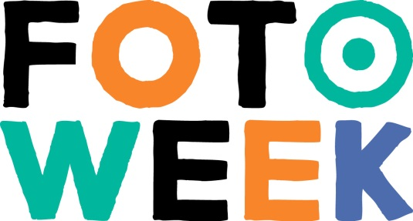

PRESS RELEASE | Amsterdam, 22 April 2015

AHMET POLAT PHOTOGRAPHER OF
THE NETHERLANDS 2015
Fotoweek presents Ahmet Polat (Roosendaal, 1978) as the third Photographer of the Netherlands [in Dutch: ‘Fotograaf des Vaderlands’], succeeding Koen Hauser. With this honorary title, Polat will be the face of Dutch photography for the coming year. Polat is currently creating a photo series for Fotoweek in the theme 'Look! My Street'. This photo series will be presented during Fotoweek 2015 at FOTODOK, international space for documentary photography, in Utrecht.

Ahmet Polat is a Turkish/Dutch documentary and fashion photographer. Polat's photos are always surprising and full of life and energy. They balance on the edge between documentary, street and fashion photography. In his work, he engages in long-term research, dealing with recurring themes such as (collective) identity, the tension between the individual and the collective, and the influence of the past on the present–always centred around the human. Due to this process, his photos convey a lot of energy, regardless of their form (documentary or fashion) or assignment.

Fotoweek is proud to present Ahmet Polat as the third Photographer of the Netherlands. Ahmet Polat is a photographer with a successful career: a perfect example of the photographic profession. With his appealing style and his ability to reveal characters, Fotoweek looks forward to his new series in the 2015 theme, 'Look! My Street'. For this Fotoweek series, Polat literally ventures into the neighbourhoods of Dutch cities and villages to document the street and its occupants in their everyday surroundings. As he collects the residents' stories, he transforms the street into the public stage it actually always was. Who does the street belong to, who are the characters who play these roles, and what are the stories that unfold in these places? On 6 September this photo series is unveiled in an exhibition at FOTODOK.

Theme 2015: Look! My Street!
With the theme 'Look! My Street', Fotoweek seeks to inspire their direct, everyday environment through the medium of photography. Neighborhood, city, lane, villa, flat, or village–every street has its own identity. This makes the public space very a personal and distinctive place. Through photography, it is possible to proudly share how we all live together in the many and varied streets of the Netherlands.

Biography Ahmet Polat
Ahmet Polat is a photographer whose work is connected to his habit of drawing. Motivated to capture the unexpected, the quality of his work has earned the deserved respect of serious critique. Since graduating from Art School Ahmet has exhibited, lectured and published prolifically, ranking the NY Times, French and Turkish Vogue, the Istanbul Modern, the Rijksmuseum and Foam among clients. Born of a Dutch mother and Turkish father, Ahmet integrates both cultures in everything he does.

---------------------

Note to editors / not for publication:
For information and visual material about the Photographer of the Netherlands please contact the communications department of Fotoweek, e-mail pers[at]defotoweek.nl or phone
+31 (0)20 5516500.

Information Fotoweek:
From Friday the 11th until Sunday, September 20th, 2015 the third edition of Fotoweek takes place. For ten days the Netherlands is dedicated to photography and there is plenty to do for everyone who loves photographs and to photograph.

Fotoweek is an initiative of Nederlands Fotomuseum and Foam Fotografiemuseum Amsterdam and is supported by BankGiro Loterij, DuPho and hazazaH.

www.defotoweek.nl
www.facebook.com/defotoweek
www.twitter.com/defotoweek #DeFotoweek #fotograafdesvaderlands
www.fotodok.org

